**Quora+ Wireframe Design**

**Login Screen**

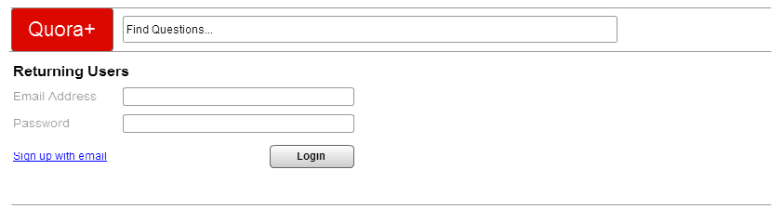

**Main Page**

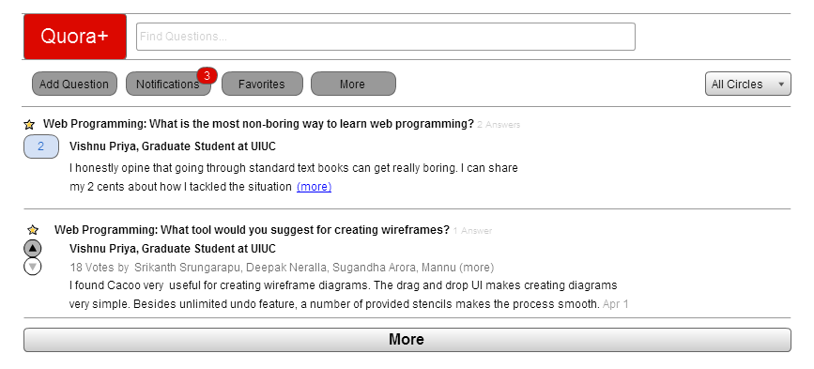

**Notifications Page**

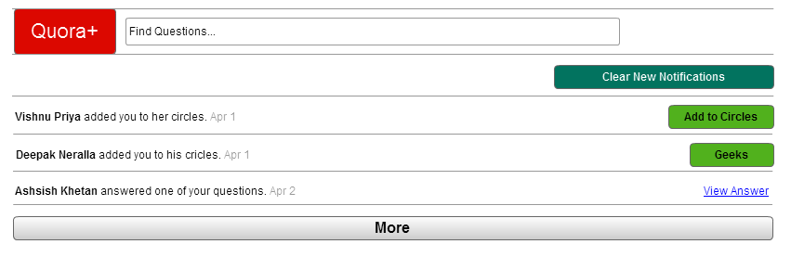

**Navigation Page**

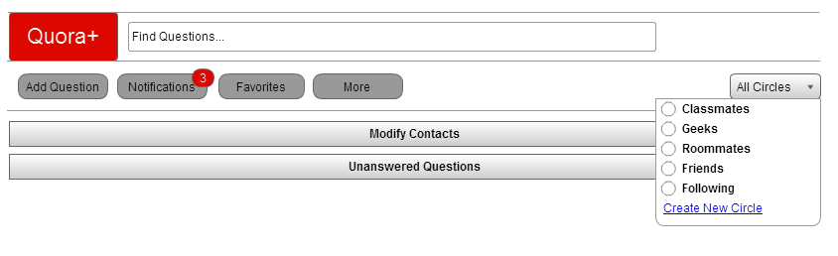

**Create Circle**

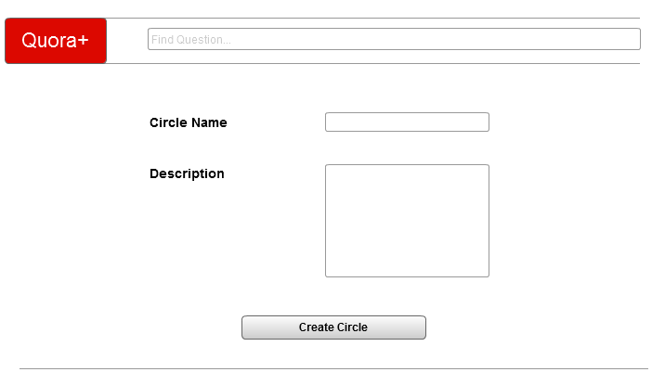

**View Contacts**

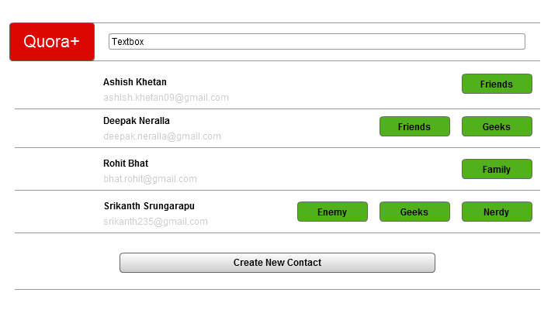

**Create Contact**

